
International School

Capstone Project 2
CMU-SE 451

User Story Document
Version 2.1
Date: Feb 24, 2022

Pet Care And Supervision Services

Submitted by

Truong Le Dai
Nguyen Hong Hieu
Tran Thi Chung
Le Quang Van

Approved by
Dr. Nguyen Tan Thuan

.
Proposal Review Panel Representative:

Name Signature Date

Capstone Project 1- Mentor: Dr. Nguyen Tan Thuan

Name Signature Date
PROJECT INFORMATION

Project acronym | Pet-care
Project Title | Pet care and Supervision services
Start Date | 20 Feb 2022 | End Date | 21 Feb 2022
Lead Institution | International School, Duy Tan University
Project Mentor | Dr. Nguyen Tan Thuan
Scrum master / Project Leader & contact details | Truong Le Dai  Email:daicatimmai123v30@gmail.com  Tel: 0774443926
Partner Organization
Project Web URL
Team members | Name | Email | Tel
24211407122 | Truong Le Dai | daicatimmai123v30@gmail.com | 799400038
24211205523 | Nguyen Hong Hieu | nguyenhonghieuit@gmail.com | 777903474
24201402277 | Tran Thi Chung | tranchung10a3@gmail.com | 945228146
24211401402 | Le Quang Van | vanlequang00@gmail.com | 898163596

User Story Document

Document Title | User Story
Reporting Period | Dec 2021
Author(s) & project | Truong Le Dai, Scrum Master
Role | Nguyen Hong Hieu | Member
 | Tran Thi Chung | Member
 | Le Quang Van | Member
Date | 21 Feb 2022 | Filename |  | C2SE.27-User Story-Pet-Care.doc
URL
Access | Project and CMU Program

REVISION HISTORY

Version | Date | Comments | Author | Approval
1.0 | 18 Sept 2021 | Initial | C2SE.27 Team | Team
1.1 | 19 Sept 2021 | Create use case diagram | C2SE.27 Team | Team
1.2 | 20 Sept 2021 | Create user stories | C2SE.27 Team | Team
1.3 | 22 Sept 2021 | Update document | C2SE.27 Team | Team
2.0 | 20 Feb 2021 | Initial | C2SE.27 Team | Team
2.1 | 21 Feb 2022 | Update document | C1SE.27 Team | Team

DOCUMENT APPROVALS

The following signatures are required for approval of this document
Dr. Nguyen Tan Thuan  Mentor |  | Date:
Truong Le Dai  Scrum Master |  | Date:
Nguyen Hong Hieu  Pruduct Owner |  | Date:
Tran Thi Chung  Member |  | Date:
Le Quang Van  Member |  | Date:

Table of Contents
1. Introduction: 7
1.1. Overview Document: 7
1.2. Project Context: 7
1.3. Use Case Diagram: 9
2. User Story: 10
2.1. Login 10
2.2. Register 11
2.3. View Pet Owner Profile 11
2.4. Edit pet owner’s profile 11
2.5. View list pets 12
2.6. Create pet profile 12
2.7. Edit pet profile 13
2.8. Delete pet profile 13
2.9. View list Veterinarian 14
2.10. Rate on Veterinarian’s profile 14
2.11. Comment on Veterinarian’s profile 14
2.12. Search Veterinarian or pets 15
2.13. View notifications 15
2.14. Delete a notification 15
2.15. View appointments 16
2.16. Request an appointment 16
2.17. Cancel an appointment 17
2.18. View list facility 17
2.19. Chat with Veterinarian 17
2.20. Video call with Veterinarian 18
2.21. Locate pet 18
2.22. Accept an Appointment 19
2.23. Refuse an appointment 19
2.24. Create an appointment 20
2.25. View schedule 20
2.26. View list pet owners 20
2.27. View profile 21
2.28. Edit profile 21
2.29. Liquidation 21
2.30. View list Veterinarian 22
2.31. View list pets 22
2.32. Chat 22
2.33. Video call 23
2.34. Manage account 23
2.35. Create an account 23
2.36. Edit an account 24
2.37. Delete an account 24
2.38. Manage facility 24
2.39. Create an facility 25
2.40. Edit an facility 25
2.41. Delete an facility 25
2.42. View Statistical 26
2.43. Export statistical 26
2.44. Posts announcements 26
3. References: 27

Introduction:
In software development, User Story (User Stories) is one or more sentences that describe the natural language (not technical language) or the business language of the end user or system user to record what users need to do or not do their job or duty. User stories are used in methods such as Agile software development as the basis for defining the functions of the system as business development and to facilitate requirements management. Help yourself know "who", "what" and "why" in a short, simple request, often limited only by details that can be written on a piece of sticky note or scrap paper.
User Stories written by business users are the primary way of the users because they understand most of the system's processes, workflows, and functions so it is up and running now. User Stories can also be written by Dev to expose non-functional requirements (like security, performance, quality, etc.).

Overview Document:
This document provides a User story and goal-oriented view of the Pet Care And Supervision Services project, providing many key benefits to the project:
- It helps answer the question: "What does this project do?" for businesses, project sponsors, developers and architects, including clearly defined scopes
- It assists in defining the target architecture and the future.
- It helps to understand the requirements needed to support a project.
- It provides a meaningful resource that can be used in conversations between the business team and the architecture.

Project Context:
- Currently, veterinary hospitals do not have an online booking system. This is very inconvenient for the patient.
- We desperately need a system that can help book appointments quickly. The Veterinarian can also see the work schedule.
- Besides, in order to meet the additional needs of pet owners and make tracking and care easier, the system has integrated GPS navigation features and effective support Users can benefit from the liquidation feature, which promises to create a potential system.
- The system has the following features:

Pet Owner :
- Create an account by phone number
- Input owner’s information
- Login into system by phone number
- View owner’s profile
- Edit owner’s profile
- View list pets
- Create/Edit/Delete pet’s profile
- View list Veterinarian
- Rate on Veterinarian’s profile
- Comments on Veterinarian’s profile
- Search Veterinarian or pets
- View notifications
- Delete/Read notification
- View appointments
- Request/Cancel an appointments
- Chat with Veterinarian
- Locate Pet
- Liquidation
Veterinarian:
- Login into the system by phone number.
- View Appointments
- View Schedule
- View list owners
- View list Veterinarian
- View list pets
- View Veterinarian’s profile
- Search owners / Veterinarians/ pets
Manager:
- Manage facility profile
- View statistic reports
- Manage Veterinarian account
- Manage pet owner account
- Post announcements
- Benefits of the system:
- Easily search enrollment information.
- User-friendly interface.

Use Case Diagram:
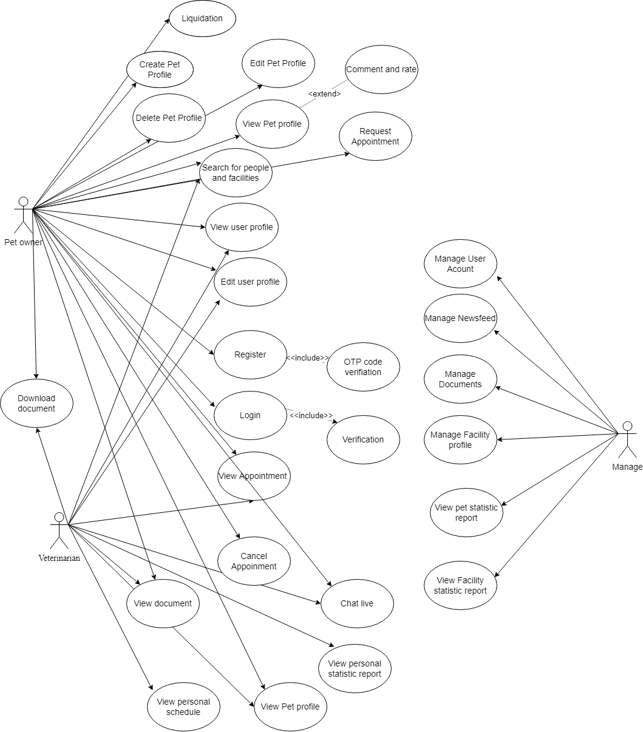
Picture 1: Use case of PetCare system
- Actors:
- Manager: system manager.
- Veterinarian: system Veterinarian.
- Pet Owner: system user.

User Story:

Login
As the user
I want to access the system with my phone number as Pet owner, Veterinarian, manager. So that when I enter the phone number and password into the [Phone Number] field, the [Password] field and then I click the login button and I can use the system .
Login | Project : PetCare | Priority: high
Story: User wants to log in to the system with their phone number. | Acceptance criteria  - User can log in to the system when owner enters correct phone number and password that owner have been registered  - Display error messages when the information is not valid.  - Length of phone number is equal to 10 or 11 number, and does not input characters.  - The first password must not be a number. Length of password is more than 6 characters, end does not input special characters.

Register
As a Pet Owner
I want to have an account to access the system. So that I input my phone number, password and confirm password to register a new account then verify OTP.
Register | Project : PetCare | Priority: low
Story: Pet owner register new an account | Acceptance Criteria  - Input your correct phone number.  - Length of phone number is equal to 10 or 11 number, and does not input characters.  - The first password must not number. Length of the password is more than 6 characters, and the end does not input special characters.

View Pet Owner Profile
As a pet owner
I want to see my profile. So that I click the icon profile in the tab bar on bottom.
View pet owner profile | Project : PetCare | Priority: medium
Story: Pet owner wants to see profile | Acceptance Criteria  - Pet owners have been logged in.

Edit pet owner’s profile
As a pet owner
I want to change my information. So that I edit information in the profile interface then click the [Xác nhận] button to update new information.
Edit profile | Project : PetCare | Priority: medium
Story: Pet owner wants to edit profile. | Acceptance Criteria  - Pet owner have been logged in.  - Don’t leave all fields blank.

View list pets
As a pet owner
I want to see all my pets which were created on the system. So that I click pet icon in tab bar on bottom
View list pets | Project : PetCare | Priority: high
Story: pet owner wants to view all user’s pets | Acceptance Criteria  - Pet owners have been logged in.  - Pet owner have created at least one pet

Create pet profile
As a pet owner
I want to input my new pet’s information on the system. So that, In the list pets interface that is clicked on the pet icon in the tab bar on the bottom I can click the [Thêm thú cưng] button to create new pet’s information.
Create pet profile | Project : PetCare | Priority: medium
Story: pet owner wants to create pet profile | Acceptance Criteria  - Pet owners have been logged in.  - Input complete information in all fields.  - Take photo or choose photo from library in all 4 fields

Edit pet profile
As a pet owner
I want to edit my pet’s information on the system. So that, In the list pets interface that is clicked pet icon in tab bar on bottom I can click [Thay đổi] button to edit pet’s information.
Edit pet profile | Project : PetCare | Priority: medium
Story: pet owner wants to edit pet’s profile | Acceptance Criteria  - Pet owner have been logged in.  - Don’t leave all fields blank.  - Pet owner created at least one pet

Delete pet profile
As a pet owner
I want to delete my pet’s information on the system. So that, In the list pets interface that is clicked on the pet icon in the tab bar on bottom I can click the delete icon to delete a pet’s information.
Delete pet profile | Project : PetCare | Priority: medium
Story: Pet owner wants to delete a pet’s information | Acceptance Criteria  - Pet owners have been logged in.  - Pet owners created at least one pet.

View list Veterinarian
As a pet owner
I want to see all Veterinarians on the system. So that, I can click the Veterinarian icon in the tab bar on bottom to view the list Veterinarians.
View List Veterinarian | Project : PetCare | Priority: medium
Story: pet owner wants to see all Veterinarians | Acceptance Criteria  - Pet owners have been logged in.

Rate on Veterinarian’s profile
As a user
I want to rate Veterinarian’s do good work or do bad work. So that, In the Veterinarian’s profile I click the rate icon to rate.
ChatBot | Project : PetCare | Priority: medium
Story: pet owner wants to rate Veterinarian | Acceptance Criteria  - Pet owner have been logged in.

Comment on Veterinarian’s profile
As a pet owner
I want to comment on Veterinarian’s profile. So that, after I rate Veterinarian, I can comments
Comment on Veterinarian’s profile | Project : PetCare | Priority: medium
Story: pet owner wants to comment on Veterinarian‘s profile | Acceptance Criteria  - Pet owners have been logged in.  - After rate Veterinarian.

Search Veterinarian or pets
As a pet owner.
I want to find Veterinarian or pets that I already know. So that, I input the data into the search toolbar on top that I want to find.
Search Veterinarians or pets | Project : PetCare | Priority: low
Story: Pet owner wants to search Veterinarians or pets. | Acceptance Criteria  - Pet owners have been logged in.  - Input the data at least one character.

View notifications
As a pet owner.
I want to know things that the system informs for user. So that, I can click the notification icon in the tab bar on bottom.
View notifications | Project : PetCare | Priority: low
Story: pet owner wants to see notifications | Acceptance Criteria  - Pet owners have been logged in.

Delete a notification
As a pet owner.
I want to delete a notification that I already read it. So that in the notification interface I can delete it.
Delete a notification | Project : PetCare | Priority: low
Story: pet owner wants to delete notification | Acceptance Criteria  - Pet owner have been logged in.  - Notifications are at least one

View appointments
As a user.
I want to see my appointments. So that if platform is OS or Android, I click appointment icon in tab bar on bottom
View appointments | Project : PetCare | Priority: low
Story: pet owner wants to see appointments | Acceptance Criteria  - Pet owner have been logged in.  - Pet owner have at least one appointment.

Request an appointment
As a pet owner.
I want to have an Veterinarian’s appointment. So that, in the appointment interface I can request a appointment to Veterinarian
Request an appointments | Project : PetCare | Priority: High
Story: pet owner wants to request an appointments | Acceptance Criteria  - Pet owner have been logged in.  - Don’t coincide with another appointment time.  - Pet owner can choose the Veterinarian who they already know or the Veterinarian is random.

Cancel an appointment
As a pet owner.
I want to cancel an appointment. So that, I cancel an appointment in the appointment interface
Cancel an appointments | Project : PetCare | Priority: High
Story: pet owner wants to cancel an appointments | Acceptance Criteria  - Pet owners have been logged in.  - Pet owners can only cancel up to 3 times in one month.

View list facility
As a pet owner.
I want to see a list of facilities. So that, I click icon on top in Veterinarian interface
Chat with Veterinarian | Project : PetCare | Priority: low
Story: pet owner wants to see list facility | Acceptance Criteria  - Pet owners have been logged in.

Chat with Veterinarian
As a pet owner.
I want to have a conversation with Veterinarian. So that, I click the icon chat on top in the home interface.
Chat with Veterinarian | Project : PetCare | Priority: High
Story: pet owner wants to chat with Veterinarian | Acceptance Criteria  - Pet owners have been logged in.  - Choose a Veterinarian to chat with.

Video call with Veterinarian
As a pet owner.
I want to have a conversation with Veterinarian. So that, I click the icon chat on top in the home interface.
Chat with Veterinarian | Project : PetCare | Priority: High
Story: pet owner wants to chat with Veterinarian | Acceptance Criteria  - Pet owners have been logged in.  - Choose a Veterinarian to chat with.

Locate pet
As a pet owner
I want to track my pet's location. So I clicked the locator button on the app, then clicked the [Confirm] button to proceed with the pet tracking via maps and GPS positioning.
Edit profile | Project : PetCare | Priority: high
Story: Pet owner want to track my pet’s location | Acceptance Criteria  - Pet owner have been logged in.  - The pet locator must be able to transmit GPS

Accept an Appointment
As a Veterinarian.
I want to accept an appointment that a pet owner requests. So that, in the appointment interface, I have the new appointment request notification.
View appointments | Project : PetCare | Priority: High
Story: Veterinarian wants to accept an appointment | Acceptance Criteria  - Veterinarians have been logged in.  - Request at least one appointment

Refuse an appointment
As a Veterinarian.
I want to refuse an appointment that a pet owner requests. So that, in the appointment interface, I have the new appointment request notification.
View appointments | Project : PetCare | Priority: High
Story: Veterinarian wants to refuse an appointment | Acceptance Criteria  - Veterinarians have been logged in.  - Request at least one appointment  - Input a reason to refuse.

Create an appointment
As a Veterinarian.
I want to create an appointment that a pet owner requests. So that, in the appointment interface I can create an appointment.
View appointments | Project : PetCare | Priority: medium
Story: Veterinarian wants to create an appointment | Acceptance Criteria  - Veterinarians have been logged in.  - Don’t leave all fields blank.

View schedule
As a Veterinarian.
I want to see my work schedule. So that I click schedule icon to view schedule
View Schedule | Project : PetCare | Priority: High
Story: Veterinarian wants to see work schedule | Acceptance Criteria  - Veterinarians have been logged in.

View list pet owners
As a Veterinarian.
I want to see all owners on the system. So that, I need a list owners button to see all owners.
View list owners | Project : PetCare | Priority: Medium
Story: Veterinarian wants to see list owners | Acceptance Criteria  - Veterinarians have been logged in.

View profile
As a pet Veterinarian
I want to see my profile. So that I click icon profile to see my profile
View Veterinarian’s profile | Project : PetCare | Priority: medium
Story: Veterinarian wants to see profile | Acceptance Criteria  - Pet owners have been logged in.

Edit profile
As a pet owner
I want to change my information. So that I edit information in the profile interface then click the [Xác nhận] button to update new information.
Edit profile | Project : PetCare | Priority: medium
Story: Veterinarian wants to edit profile. | Acceptance Criteria  - Pet owners have been logged in.  - Don’t leave all fields blank.

Liquidation
As a pet owner
I want to track my pet's location. So I clicked the locator button on the app, then clicked the [Confirm] button to proceed with the pet tracking via maps and GPS positioning.
Edit profile | Project : PetCare | Priority: high
Story: Pet owner want to track my pet’s location | Acceptance Criteria  - Pet owners have been logged in.  - The pet locator must be able to transmit GPS

View list Veterinarian
As a Veterinarian.
I want to see all veterinarians on the system. So that, I need a list of Veterinarian buttons to see all Veterinarians.
View list Veterinarian | Project : PetCare | Priority: Medium
Story: Veterinarian wants to see list Veterinarian | Acceptance Criteria  - Veterinarians have been logged in.

View list pets
As a Veterinarian.
I want to see all pets on the system. So that, I need a list of pets buttons to see all pets.
View list pets | Project : PetCare | Priority: Medium
Story: Veterinarian wants to see list pets | Acceptance Criteria  - Veterinarians have been logged in.

Chat
As a Veterinarian.
I want to have conversations with pet owners, veterinarians and group. So that, I needs to have chat functionality
Chat | Project : PetCare | Priority: High
Story:Veterinarian wants to chat | Acceptance Criteria  - Veterinarians have been logged in.

Video call
As a Veterinarian.
I want to have a conversation with a pet owner, a Veterinarian, and a group via video. So, I need to have video call functionality.
Chat | Project : PetCare | Priority: High
Story: Veterinarian wants to video call | Acceptance Criteria  - Veterinarians have been logged in.

Manage account
As a manager.
I want to manage all accounts. So that, I need to create, edit, and delete an account.
Manage | Project : PetCare | Priority: Low
Story: Manager wants to manage the account. | Acceptance Criteria  - Manager has been logged in.

Create an account
As a manager.
I want to create an account for veterinarians. So that I need to have create an account function
Create an account | Project : PetCare | Priority: Low
Story: Manager wants to edit account | Acceptance Criteria  - Manager has been logged in.  - Do not leave all fields blank.

Edit an account
As a Manager.
I want to edit an account for Veterinarian. So that I need to have edit an account function
edit an account | Project : PetCare | Priority: Low
Story: Manager wants to edit account | Acceptance Criteria  - Manager has been logged in.  - Do not leave all fields blank.

Delete an account
As a manager.
I want to delete an account for Veterinarian. So that I need to have delete an account function
edit an account | Project : PetCare | Priority: Low
Story: Manager wants to delete account | Acceptance Criteria  - Manager has been logged in.

Manage facility
As a manager.
I want to manage all my facilities. So that I need to have manage an facility function
Manage facility | Project : PetCare | Priority: Low
Story: Manager wants to manage facility | Acceptance Criteria  - Manager has been logged in.

Create an facility
As a manager.
I want to create a facility. So that I need to have create an facility function
Create an facility | Project : PetCare | Priority: low
Story: Manager wants to create facility | Acceptance Criteria  - Manager has been logged in.  - Do not leave all fields blank.

Edit an facility
As a manager.
I want to edit a facility. So that I need to have edit an facility function
Edit an facility | Project : PetCare | Priority: Low
Story: Manager wants to edit facility | Acceptance Criteria  - Manager has been logged in.  - Do not leave all fields blank.

Delete an facility
As a manager.
I want to delete an facility. So that I need to have delete an facility function
Edit an facility | Project : PetCare | Priority: Low
Story: Manager wants to delete facility | Acceptance Criteria  - Manager have been logged in.

View Statistical
As a manager.
I want to see my statistics. So that I need to have view statistical function
View statistical | Project : PetCare | Priority: low
Story: Manager wants to see statistical | Acceptance Criteria  - Manager has been logged in.

Export statistical
As a manager.
I want to export statistics. So that I need to have export statistical function
Export statistical | Project : PetCare | Priority: low
Story: Manager wants to export statistical | Acceptance Criteria  - Manager has been logged in.

Posts announcements
As a manager.
I want to make an announcement. So that I need to have posts announcements function
Posts announcements | Project : PetCare | Priority: low
Story: Manager wants to make an announcement | Acceptance Criteria  - Manager has been logged in.

  - Admin profile
As a manager
I want to view manager's own functions. So that I need to have posts announcements function
Admin profile | Project : PetCare | Priority: medium
Story: Manager wants to view manager's own functions | Acceptance Criteria  - Manager has been logged in.

  - Add Device

As a Pet Owner
I want to add a device to locate my pet. So that I need add device
Add Device | Project : PetCare | Priority: high
Story: Pet Owner want to add a device to locate my pet | Acceptance Criteria  - Pet Owner has been logged in.

References:
[1]. Scrum Process: A gentle introduction - https://scrumguides.org/
[2]. Scrum Guide - https://scrumguides.org/scrum-guide.html
[3]. https://en.wikipedia.org/wiki/Scrum_(software_development)

